Web Programming Lab

Lab 02 – Arhaan Girdhar : 220962050

Q1. Create a web page using bootstrap as mentioned. Divide the page in to 2 parts top and bottom, then divide the bottom into 3 parts and design each top and bottom part using different input groups, input, badges, buttons and button groups. Make the design more attractive using bootstrap.

<!DOCTYPE html>
<html lang="en">
<head>
<meta charset="UTF-8">
<meta name="viewport" content="width=device-width, initial-scale=1.0">
<title>Bootstrap Page</title>
<link href="https://cdn.jsdelivr.net/npm/bootstrap@5.3.0-alpha1/dist/css/bootstrap.min.css" rel="stylesheet">
<style>
body {
background-color: #343a40;
color: #f8f9fa;
}
.top-section {
background-color: #495057;
padding: 50px;
border-bottom: 2px solid #6c757d;
}
.bottom-section {
padding: 30px;
}
.item {
background-color: #495057;
padding: 20px;
margin-bottom: 20px;
border-radius: 8px;
}
.input-group-text {
background-color: #6c757d;
color: #f8f9fa;
}
.form-control {
background-color: #6c757d;
color: #f8f9fa;
border: 1px solid #6c757d;
}
.badge {
color: #f8f9fa;
}
.btn-group .btn {
color: #f8f9fa;
}
.btn-success {
background-color: #28a745;
border-color: #28a745;
}
.btn-danger {
background-color: #dc3545;
border-color: #dc3545;
}
.btn-warning {
background-color: #ffc107;
border-color: #ffc107;
}
.btn-info {
background-color: #17a2b8;
border-color: #17a2b8;
}
.footer-name{
margin-left: 80vh;
}
</style>
</head>
<body>

<div class="top-section">
<div class="container">
<h2 class="text-center mb-4">Top Section</h2>
<div class="row">
<div class="col-md-6">
<div class="input-group mb-3">
<span class="input-group-text">@</span>
<input type="text" class="form-control" placeholder="Username">
</div>
</div>
<div class="col-md-6">
<div class="input-group mb-3">
<input type="text" class="form-control" placeholder="Email">
<span class="input-group-text">@example.com</span>
</div>
</div>
</div>

<div class="row">
<div class="col-md-6">
<h5>Notifications <span class="badge bg-primary">4</span></h5>
</div>
<div class="col-md-6 text-end">
<div class="btn-group">
<button type="button" class="btn btn-success">Save</button>
<button type="button" class="btn btn-danger">Cancel</button>
</div>
</div>
</div>
</div>
</div>

<div class="bottom-section">
<div class="container">
<h2 class="text-center mb-4">Bottom Section</h2>
<div class="row">
<div class="col-md-4">
<div class="item">
<h5>Item 1</h5>
<button type="button" class="btn btn-primary">Button 1</button>
<span class="badge bg-secondary">New</span>
</div>
</div>
<div class="col-md-4">
<div class="item">
<h5>Item 2</h5>
<button type="button" class="btn btn-warning">Button 2</button>
<span class="badge bg-danger">Out of Stock</span>
</div>
</div>
<div class="col-md-4">
<div class="item">
<h5>Item 3</h5>
<button type="button" class="btn btn-info">Button 3</button>
<span class="badge bg-success">In Stock</span>
</div>
</div>
</div>
</div>
</div>
<footer class = "footer-name">
<p>&copy; 2025 Arhaan Girdhar</p>
</footer>
<script src="https://cdn.jsdelivr.net/npm/bootstrap@5.3.0-alpha1/dist/js/bootstrap.bundle.min.js"></script>
</body>
</html>

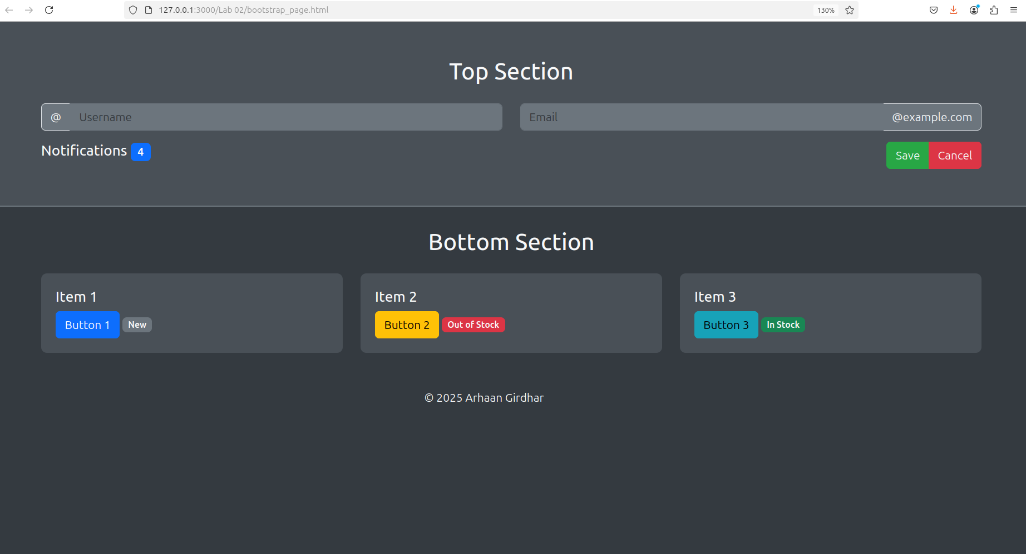

Q2. Design your class timetable using bootstrap table and carousel.

<!DOCTYPE html>
<html lang="en">
<head>
<meta charset="UTF-8">
<meta name="viewport" content="width=device-width, initial-scale=1.0">
<title>Timetable</title>
<link href="https://cdn.jsdelivr.net/npm/bootstrap@5.3.0-alpha1/dist/css/bootstrap.min.css" rel="stylesheet">
<style>
body {
background-color: #f8f9fa;
color: #343a40;
}
.carousel-item {
background-color: #ffffff;
padding: 20px;
border-radius: 8px;
}
.table {
background-color: #ffffff;
}
.table th, .table td {
text-align: center;
}
.btn-group .btn {
margin: 5px;
}
.carousel-indicators li {
background-color: #b6d8fc;
}
.carousel-inner {
text-align: center;
}
.btn-info {
background-color: #bbfdff;
border-color: #000000;
}
.btn-info:hover {
background-color: #2c5986;
border-color: #ffffff;
}
.btn-group {
display: flex;
justify-content: center;
margin-top: 20px;
}
.container {
max-width: 1000px;
}
.footer-name{
margin-left: 80vh;
}
</style>
</head>
<body>

<div class="container mt-4">
<h2 class="text-center mb-4">My Timetable</h2>

<div id="carouselExample" class="carousel slide" data-bs-ride="carousel">
<div class="carousel-inner">
<!-- Monday -->
<div class="carousel-item active">
<h4 class="text-center">Monday</h4>
<table class="table table-bordered">
<thead>
<tr>
<th>Time</th>
<th>Subject</th>
<th>Instructor</th>
</tr>
</thead>
<tbody>
<tr>
<td>8:00 AM - 9:00 AM</td>
<td>Mathematics (Calculus)</td>
<td>Dr. Smith</td>
</tr>
<tr>
<td>9:00 AM - 10:00 AM</td>
<td>Engineering Physics</td>
<td>Dr. Johnson</td>
</tr>
<tr>
<td>10:00 AM - 11:00 AM</td>
<td>Electrical Circuits</td>
<td>Prof. Brown</td>
</tr>
<tr>
<td>11:00 AM - 12:00 PM</td>
<td>Engineering Drawing</td>
<td>Dr. Taylor</td>
</tr>
</tbody>
</table>
</div>
<!-- Tuesday -->
<div class="carousel-item">
<h4 class="text-center">Tuesday</h4>
<table class="table table-bordered">
<thead>
<tr>
<th>Time</th>
<th>Subject</th>
<th>Instructor</th>
</tr>
</thead>
<tbody>
<tr>
<td>8:00 AM - 9:00 AM</td>
<td>Digital Logic Design</td>
<td>Prof. Green</td>
</tr>
<tr>
<td>9:00 AM - 10:00 AM</td>
<td>Fluid Mechanics</td>
<td>Dr. White</td>
</tr>
<tr>
<td>10:00 AM - 11:00 AM</td>
<td>Thermodynamics</td>
<td>Ms. Black</td>
</tr>
<tr>
<td>11:00 AM - 12:00 PM</td>
<td>Computer Programming</td>
<td>Dr. Blue</td>
</tr>
</tbody>
</table>
</div>
<!-- Wednesday -->
<div class="carousel-item">
<h4 class="text-center">Wednesday</h4>
<table class="table table-bordered">
<thead>
<tr>
<th>Time</th>
<th>Subject</th>
<th>Instructor</th>
</tr>
</thead>
<tbody>
<tr>
<td>8:00 AM - 9:00 AM</td>
<td>Mathematics (Linear Algebra)</td>
<td>Dr. Gray</td>
</tr>
<tr>
<td>9:00 AM - 10:00 AM</td>
<td>Mechanics of Solids</td>
<td>Ms. White</td>
</tr>
<tr>
<td>10:00 AM - 11:00 AM</td>
<td>Control Systems</td>
<td>Dr. Smith</td>
</tr>
<tr>
<td>11:00 AM - 12:00 PM</td>
<td>Circuit Analysis</td>
<td>Dr. Johnson</td>
</tr>
</tbody>
</table>
</div>
<!-- Thursday -->
<div class="carousel-item">
<h4 class="text-center">Thursday</h4>
<table class="table table-bordered">
<thead>
<tr>
<th>Time</th>
<th>Subject</th>
<th>Instructor</th>
</tr>
</thead>
<tbody>
<tr>
<td>8:00 AM - 9:00 AM</td>
<td>Material Science</td>
<td>Prof. Red</td>
</tr>
<tr>
<td>9:00 AM - 10:00 AM</td>
<td>Fluid Mechanics Lab</td>
<td>Dr. White</td>
</tr>
<tr>
<td>10:00 AM - 11:00 AM</td>
<td>Mechanical Drawing</td>
<td>Ms. Black</td>
</tr>
<tr>
<td>11:00 AM - 12:00 PM</td>
<td>Programming Lab</td>
<td>Dr. Blue</td>
</tr>
</tbody>
</table>
</div>
<!-- Friday -->
<div class="carousel-item">
<h4 class="text-center">Friday</h4>
<table class="table table-bordered">
<thead>
<tr>
<th>Time</th>
<th>Subject</th>
<th>Instructor</th>
</tr>
</thead>
<tbody>
<tr>
<td>8:00 AM - 9:00 AM</td>
<td>Mathematics (Probability)</td>
<td>Dr. White</td>
</tr>
<tr>
<td>9:00 AM - 10:00 AM</td>
<td>Fluid Mechanics</td>
<td>Dr. Green</td>
</tr>
<tr>
<td>10:00 AM - 11:00 AM</td>
<td>Dynamics</td>
<td>Prof. Red</td>
</tr>
<tr>
<td>11:00 AM - 12:00 PM</td>
<td>Control Systems Lab</td>
<td>Dr. Smith</td>
</tr>
</tbody>
</table>
</div>
<!-- Saturday -->
<div class="carousel-item">
<h4 class="text-center">Saturday</h4>
<table class="table table-bordered">
<thead>
<tr>
<th>Time</th>
<th>Subject</th>
<th>Instructor</th>
</tr>
</thead>
<tbody>
<tr>
<td>8:00 AM - 9:00 AM</td>
<td>Signals & Systems</td>
<td>Dr. Brown</td>
</tr>
<tr>
<td>9:00 AM - 10:00 AM</td>
<td>Electronic Circuits</td>
<td>Ms. Black</td>
</tr>
<tr>
<td>10:00 AM - 11:00 AM</td>
<td>Strength of Materials</td>
<td>Prof. Green</td>
</tr>
<tr>
<td>11:00 AM - 12:00 PM</td>
<td>Computational Methods</td>
<td>Dr. Red</td>
</tr>
</tbody>
</table>
</div>
</div>
<div class="carousel-indicators">
<button type="button" data-bs-target="#carouselExample" data-bs-slide-to="0" class="active"></button>
<button type="button" data-bs-target="#carouselExample" data-bs-slide-to="1"></button>
<button type="button" data-bs-target="#carouselExample" data-bs-slide-to="2"></button>
<button type="button" data-bs-target="#carouselExample" data-bs-slide-to="3"></button>
<button type="button" data-bs-target="#carouselExample" data-bs-slide-to="4"></button>
<button type="button" data-bs-target="#carouselExample" data-bs-slide-to="5"></button>
</div>
</div>

<div class="btn-group mt-3" role="group">
<button type="button" class="btn btn-info" data-bs-target="#carouselExample" data-bs-slide-to="0">Monday</button>
<button type="button" class="btn btn-info" data-bs-target="#carouselExample" data-bs-slide-to="1">Tuesday</button>
<button type="button" class="btn btn-info" data-bs-target="#carouselExample" data-bs-slide-to="2">Wednesday</button>
<button type="button" class="btn btn-info" data-bs-target="#carouselExample" data-bs-slide-to="3">Thursday</button>
<button type="button" class="btn btn-info" data-bs-target="#carouselExample" data-bs-slide-to="4">Friday</button>
<button type="button" class="btn btn-info" data-bs-target="#carouselExample" data-bs-slide-to="5">Saturday</button>
</div>
</div>
<footer class = "footer-name">
<p>&copy; 2025 Arhaan Girdhar</p>
</footer>
<script src="https://cdn.jsdelivr.net/npm/bootstrap@5.3.0-alpha1/dist/js/bootstrap.bundle.min.js"></script>
</body<!DOCTYPE html>
<html lang="en">
<head>
<meta charset="UTF-8">
<meta name="viewport" content="width=device-width, initial-scale=1.0">
<title>Timetable</title>
<link href="https://cdn.jsdelivr.net/npm/bootstrap@5.3.0-alpha1/dist/css/bootstrap.min.css" rel="stylesheet">
<style>
body {
background-color: #f8f9fa;
color: #343a40;
}
.carousel-item {
background-color: #ffffff;
padding: 20px;
border-radius: 8px;
}
.table {
background-color: #ffffff;
}
.table th, .table td {
text-align: center;
}
.btn-group .btn {
margin: 5px;
}
.carousel-indicators li {
background-color: #b6d8fc;
}
.carousel-inner {
text-align: center;
}
.btn-info {
background-color: #bbfdff;
border-color: #000000;
}
.btn-info:hover {
background-color: #2c5986;
border-color: #ffffff;
}
.btn-group {
display: flex;
justify-content: center;
margin-top: 20px;
}
.container {
max-width: 1000px;
}
.footer-name{
margin-left: 80vh;
}
</style>
</head>
<body>

<div class="container mt-4">
<h2 class="text-center mb-4">My Timetable</h2>

<div id="carouselExample" class="carousel slide" data-bs-ride="carousel">
<div class="carousel-inner">
<!-- Monday -->
<div class="carousel-item active">
<h4 class="text-center">Monday</h4>
<table class="table table-bordered">
<thead>
<tr>
<th>Time</th>
<th>Subject</th>
<th>Instructor</th>
</tr>
</thead>
<tbody>
<tr>
<td>8:00 AM - 9:00 AM</td>
<td>Mathematics (Calculus)</td>
<td>Dr. Smith</td>
</tr>
<tr>
<td>9:00 AM - 10:00 AM</td>
<td>Engineering Physics</td>
<td>Dr. Johnson</td>
</tr>
<tr>
<td>10:00 AM - 11:00 AM</td>
<td>Electrical Circuits</td>
<td>Prof. Brown</td>
</tr>
<tr>
<td>11:00 AM - 12:00 PM</td>
<td>Engineering Drawing</td>
<td>Dr. Taylor</td>
</tr>
</tbody>
</table>
</div>
<!-- Tuesday -->
<div class="carousel-item">
<h4 class="text-center">Tuesday</h4>
<table class="table table-bordered">
<thead>
<tr>
<th>Time</th>
<th>Subject</th>
<th>Instructor</th>
</tr>
</thead>
<tbody>
<tr>
<td>8:00 AM - 9:00 AM</td>
<td>Digital Logic Design</td>
<td>Prof. Green</td>
</tr>
<tr>
<td>9:00 AM - 10:00 AM</td>
<td>Fluid Mechanics</td>
<td>Dr. White</td>
</tr>
<tr>
<td>10:00 AM - 11:00 AM</td>
<td>Thermodynamics</td>
<td>Ms. Black</td>
</tr>
<tr>
<td>11:00 AM - 12:00 PM</td>
<td>Computer Programming</td>
<td>Dr. Blue</td>
</tr>
</tbody>
</table>
</div>
<!-- Wednesday -->
<div class="carousel-item">
<h4 class="text-center">Wednesday</h4>
<table class="table table-bordered">
<thead>
<tr>
<th>Time</th>
<th>Subject</th>
<th>Instructor</th>
</tr>
</thead>
<tbody>
<tr>
<td>8:00 AM - 9:00 AM</td>
<td>Mathematics (Linear Algebra)</td>
<td>Dr. Gray</td>
</tr>
<tr>
<td>9:00 AM - 10:00 AM</td>
<td>Mechanics of Solids</td>
<td>Ms. White</td>
</tr>
<tr>
<td>10:00 AM - 11:00 AM</td>
<td>Control Systems</td>
<td>Dr. Smith</td>
</tr>
<tr>
<td>11:00 AM - 12:00 PM</td>
<td>Circuit Analysis</td>
<td>Dr. Johnson</td>
</tr>
</tbody>
</table>
</div>
<!-- Thursday -->
<div class="carousel-item">
<h4 class="text-center">Thursday</h4>
<table class="table table-bordered">
<thead>
<tr>
<th>Time</th>
<th>Subject</th>
<th>Instructor</th>
</tr>
</thead>
<tbody>
<tr>
<td>8:00 AM - 9:00 AM</td>
<td>Material Science</td>
<td>Prof. Red</td>
</tr>
<tr>
<td>9:00 AM - 10:00 AM</td>
<td>Fluid Mechanics Lab</td>
<td>Dr. White</td>
</tr>
<tr>
<td>10:00 AM - 11:00 AM</td>
<td>Mechanical Drawing</td>
<td>Ms. Black</td>
</tr>
<tr>
<td>11:00 AM - 12:00 PM</td>
<td>Programming Lab</td>
<td>Dr. Blue</td>
</tr>
</tbody>
</table>
</div>
<!-- Friday -->
<div class="carousel-item">
<h4 class="text-center">Friday</h4>
<table class="table table-bordered">
<thead>
<tr>
<th>Time</th>
<th>Subject</th>
<th>Instructor</th>
</tr>
</thead>
<tbody>
<tr>
<td>8:00 AM - 9:00 AM</td>
<td>Mathematics (Probability)</td>
<td>Dr. White</td>
</tr>
<tr>
<td>9:00 AM - 10:00 AM</td>
<td>Fluid Mechanics</td>
<td>Dr. Green</td>
</tr>
<tr>
<td>10:00 AM - 11:00 AM</td>
<td>Dynamics</td>
<td>Prof. Red</td>
</tr>
<tr>
<td>11:00 AM - 12:00 PM</td>
<td>Control Systems Lab</td>
<td>Dr. Smith</td>
</tr>
</tbody>
</table>
</div>
<!-- Saturday -->
<div class="carousel-item">
<h4 class="text-center">Saturday</h4>
<table class="table table-bordered">
<thead>
<tr>
<th>Time</th>
<th>Subject</th>
<th>Instructor</th>
</tr>
</thead>
<tbody>
<tr>
<td>8:00 AM - 9:00 AM</td>
<td>Signals & Systems</td>
<td>Dr. Brown</td>
</tr>
<tr>
<td>9:00 AM - 10:00 AM</td>
<td>Electronic Circuits</td>
<td>Ms. Black</td>
</tr>
<tr>
<td>10:00 AM - 11:00 AM</td>
<td>Strength of Materials</td>
<td>Prof. Green</td>
</tr>
<tr>
<td>11:00 AM - 12:00 PM</td>
<td>Computational Methods</td>
<td>Dr. Red</td>
</tr>
</tbody>
</table>
</div>
</div>
<div class="carousel-indicators">
<button type="button" data-bs-target="#carouselExample" data-bs-slide-to="0" class="active"></button>
<button type="button" data-bs-target="#carouselExample" data-bs-slide-to="1"></button>
<button type="button" data-bs-target="#carouselExample" data-bs-slide-to="2"></button>
<button type="button" data-bs-target="#carouselExample" data-bs-slide-to="3"></button>
<button type="button" data-bs-target="#carouselExample" data-bs-slide-to="4"></button>
<button type="button" data-bs-target="#carouselExample" data-bs-slide-to="5"></button>
</div>
</div>

<div class="btn-group mt-3" role="group">
<button type="button" class="btn btn-info" data-bs-target="#carouselExample" data-bs-slide-to="0">Monday</button>
<button type="button" class="btn btn-info" data-bs-target="#carouselExample" data-bs-slide-to="1">Tuesday</button>
<button type="button" class="btn btn-info" data-bs-target="#carouselExample" data-bs-slide-to="2">Wednesday</button>
<button type="button" class="btn btn-info" data-bs-target="#carouselExample" data-bs-slide-to="3">Thursday</button>
<button type="button" class="btn btn-info" data-bs-target="#carouselExample" data-bs-slide-to="4">Friday</button>
<button type="button" class="btn btn-info" data-bs-target="#carouselExample" data-bs-slide-to="5">Saturday</button>
</div>
</div>
<footer class = "footer-name">
<p>&copy; 2025 Arhaan Girdhar</p>
</footer>
<script src="https://cdn.jsdelivr.net/npm/bootstrap@5.3.0-alpha1/dist/js/bootstrap.bundle.min.js"></script>
</body>
</html>>
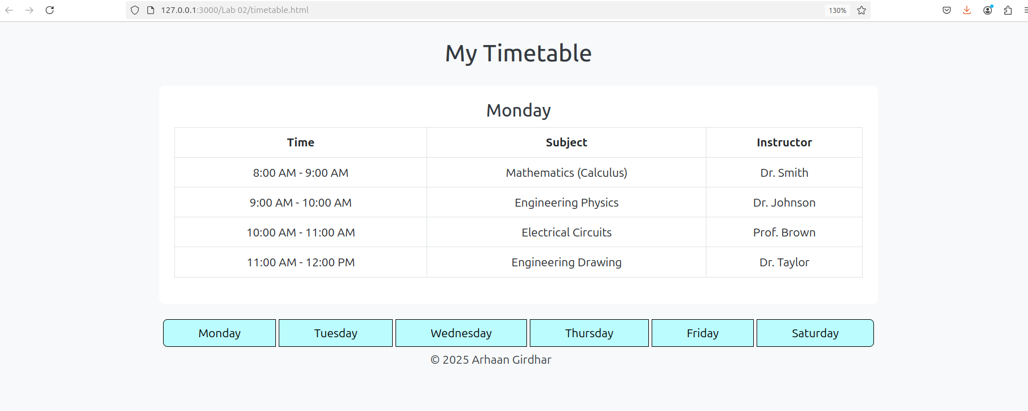
</html>

Q3. Design an attractive ‘train ticket booking form using CSS.

~ HTML~

<!DOCTYPE html>
<html lang="en">
<head>
<meta charset="UTF-8">
<meta name="viewport" content="width=device-width, initial-scale=1.0">
<title>Train Booking</title>
<link rel="stylesheet" href="styles.css">
</head>
<body>
<div class="background-image">
<div class="form-container">
<h2>Train Ticket Booking</h2>
<form action="#" method="POST">
<div class="form-group">
<label for="departure">Departure Station:</label>
<input type="text" id="departure" name="departure" required placeholder="Enter departure station">
</div>

<div class="form-group">
<label for="arrival">Arrival Station:</label>
<input type="text" id="arrival" name="arrival" required placeholder="Enter arrival station">
</div>

<div class="form-group">
<label for="date">Travel Date:</label>
<input type="date" id="date" name="date" required>
</div>

<div class="form-group">
<label for="passenger-name">Passenger Name:</label>
<input type="text" id="passenger-name" name="passenger-name" required placeholder="Enter your name">
</div>

<div class="form-group">
<label for="number-of-tickets">Number of Tickets:</label>
<input type="number" id="number-of-tickets" name="number-of-tickets" min="1" max="10" required>
</div>

<div class="form-group">
<button type="submit" class="btn-submit">Book Ticket</button>
</div>
</form>
</div>
</div>
</body>
</html>

~ CSS ~

* {
margin: 0;
padding: 0;
box-sizing: border-box;
}

body {
font-family: Arial, sans-serif;
background-color: #121212;
color: #f0f0f0;
display: flex;
justify-content: center;
align-items: center;
height: 100vh;
}

.background-image {
background-image: url('bg.png');
background-size: cover;
background-position: center;
width: 100%;
height: 100%;
position: absolute;
top: 0;
left: 0;
}

.form-container {
background-color: rgba(0, 0, 0, 0.7);
padding: 40px;
border-radius: 10px;
width: 100%;
max-width: 400px;
box-shadow: 0 4px 8px rgba(0, 0, 0, 0.5);
}

h2 {
text-align: center;
color: #ffffff;
margin-bottom: 20px;
}

.form-group {
margin-bottom: 20px;
}

label {
display: block;
font-size: 14px;
color: #bbb;
margin-bottom: 5px;
}

input[type="text"],
input[type="date"],
input[type="number"] {
width: 100%;
padding: 10px;
background-color: #333;
border: 1px solid #444;
border-radius: 5px;
color: #fff;
font-size: 14px;
}

input[type="text"]:focus,
input[type="date"]:focus,
input[type="number"]:focus {
border-color: #f0f0f0;
outline: none;
}

button.btn-submit {
width: 100%;
padding: 12px;
background-color: #4CAF50;
color: white;
border: none;
border-radius: 5px;
font-size: 16px;
cursor: pointer;
transition: background-color 0.3s;
}

button.btn-submit:hover {
background-color: #45a049;
}

button.btn-submit:focus {
outline: none;
}

